1st Edition 2008
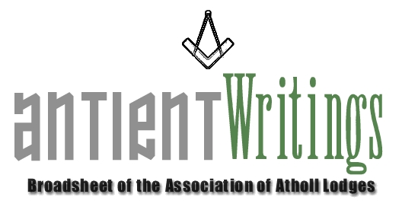

Annual General Meeting

The 2008 Annual General Meeting will be held at Freemasons Hall, Gt Queen Street, on Wed 2nd July starting at 6pm. Unfortunately the Clerkenwell Masonic Centre could not accommodate us on this date.
All are welcome so please send along a representative. Should any subscribing lodge wish to bring forward a ‘Notice of Motion’ please submit it in writing to the Secretary by 4th June 2008.

New Blood

Are you !!! - Interested in joining the Executive Committee, which meets 3 times a year in London. The Committee will soon be actively succession planning for experienced brethren to take on the roles of:

1. Secretary 2. Asst Secretary [Membership]
  - Directors of Ceremony [x2] 4. Events Organiser

It is hoped that many of the Atholl lodges will respond to this appeal and put forward willing brethren to maintain the momentum of the Association through membership of its Executive Committee.

It is with sadness we report the death of our membership secretary Rod Letherby . He did a great deal to widen and encourage membership of the Association . He will be missed.

Web Site - www.antients.com and webmaster@antients.com

The webmaster is keen to enhance the ‘Regions’ pages to include ‘info’ and ‘chat’ from any Atholls around the country. Please send any submissions to him [above]. You can also have a ‘click-on’ to your lodge’s web site from the listing page if you wish.

Jamaica Visit May 2008

Following very limited response the trip to our two Lodges in Jamaica has been postponed until 2009/10.

Midlands Meeting

Picking up on a suggestion that one of the Executive meetings be held ‘around the country’ Athol Lodge No 74 has kindly offered. It will be on Wed 1st October 2008 at Birmingham [Severn Street]. The committee meeting will start at 4pm sharp and be followed by the Lodge Regular meeting at which there will be an AAL input. Please try to come ! Details will be publicised in the next edition of Antient Writings.

Merchandise

There is now a new stock of Ties / Bow Ties and Lapel Pins and available from the Secretary. They are £12.50 and £2.50 respectively. You are permitted to wear Association ties at Atholl meetings.

New Hope – Rescue a Lodge

The Secretary is aware of a group of ‘Atholl’ enthusiasts who are willing to ‘rescue’ an antient lodge rather than let it surrender its Warrant. The plan would be to enrich its membership and move it to Sindlesham, Berkshire where it would have a secure home and future. Any lodge in such straits please make contact.

Would Secretaries and Representatives photocopy and distribute as widely as possible

Paul Gardner - 39 Wentworth Drive, Bedford, BEDS, MK41 8QA - 01234 261584 secretary@antients.com

